Shrimp Task Force Meeting
Wednesday, January 4, 2023, 10:00am
LDWF Headquarters
2000 Quail Drive
Baton Rouge, LA 70808

I. Pledge of Allegiance
II. Roll call and introduction of guests
Voting Members Present:
Rodney Olander
Acy Cooper
Kristen Baumer
Alan Gibson
Andrew Blanchard
Randy Pearce

Voting Members Absent:
Lance Nacio
Jeff Drury
Phillip Tran
Chalin Delaune

Non-Voting Members Present:
Peyton Cagle
Edward Skena
Jack Isaacs
Justin Gremillion

Non-Voting Members Absent:
Olivia Ledet
Gene Cavalier

III. Rodney Olander motioned to approve the November 2, 2022 meeting minutes, 2nd by Kristen Baumer. Motion carries.
IV. Rodney Olander motioned to approve the January 4, 2023 meeting agenda, 2nd by Kristen Baumer. Motion carries.
V. Financial report
Remaining Fund Balance- $693,722
Remaining Budget Balance- $270,331

Andrew Blanchard motioned to approve the financial report as presented, 2nd by Kristen Baumer. Motion carries.
VI. The task force was presented with an updated Federal Shrimp Permit list
VII. New Business-
- The task force went into executive session to discuss the matter of Louisiana State vs. Dept. of Commerce et al. (TEDs in Skimmers)
Alan Gibson motioned for the board to enter into executive session to discuss the matter of Louisiana State vs. Dept. of Commerce et al. (TEDs in Skimmers), 2nd by Rodney Olander. Motion carries
Board entered executive session
Alan Gibson motioned for the board to exit executive session, 2nd by Kristen Baumer. Motion carries.
Rodney Olander motioned to resume the Shrimp Task Force public meeting 2nd by Alan Gibson. Motion carries.
- The board discussed and considered possible amendments to Act 372- the shrimp label of origin bill
Acy Cooper stated that there is no meat to the bill, would like to propose amendments. Would like for restaurants to have to provide information on where the shrimp and crawfish are from and have to abide by the regulations that are there.
This is currently a non-critical violation, critical violations are those that can lead to immediate health hazards non-critical are not immediate, if LDH goes in and sees 5 or more non-critical violations that are not corrected during the visit they fail the inspection and get a re-inspection, if any critical violations are found and are not corrected on the spot it is a failed inspection- come back the next day or with-in 48 hours and if still failed inspection will be fined at this point about $150 fine if 2nd inspection is failed, starting to see this improvement
Dr. Kanter and Secretary if Health Dr. Courtney come together to decide on what needs to be critical or non-critical violations- doesn’t happen too often that these violations switch categories
Acy Cooper stated that he has amendments to propose, asked what will be needed to get the LDWF involved in enforcing this, right now it’s a LDH rule that is done through their administrative code
Justin Gremillion stated that been collecting samples and everything has come back negative- testing for class of antibiotic, have the right to destroy it if tests positive for antibiotics,
Acy Cooper how can LDWF be involved in the inspection process, would like to sit down with LDWF to discuss further
Randy Pearce stated that it took 20 years to pass this law, need more teeth to it, marketing list of restaurants who are not complying, more amendments to add more teeth to it, higher fines
Dean Blanchard stated that need to charge the importers to have the product tested
In 2019-618 violations were written, in 2020-757, in 2021-681, in 2022-411- eatsafe.la.gov
Justin Gremillion will get the information to the TF on the list of restaurants not in compliance
Justin Gremillion stated that reach out to FDA counterpart and ask if there is a target that we should expand to
- The board discussed the St. Bernard ordinance on banning imported shrimp
Fred Everhardt, St. Bernard Parish Councilman, stated that something has to be done to protect the health, safety and wellbeing of the residents, worked with legal and found a door where we can try and enforce this ordinace, working on getting other municipalities and parishes on board and follow this ordinance need other parishes support on this, the whole objective is to get the State to be the first state in the country to ban imported seafood causing a multitude of issues to the constituents- 90 day grace period to get rid of whatever seafood they have that might be imported, this is a living document and can be changed/ edited if needed
Acy Cooper stated that he has been working with Fred Everhardt and wants to try and get as many coastal parishes to participate as possible
Rodney Olander stated that St. Mary Parish is ready to move forward, concerned with having enough domestic shrimp in all areas to replace the imported shrimp
The ordinance goes into effect 90 days from December 7, 2022, will have to go through the BAA board- Plaquemines is moving forward with it
- Jason Froeba provided an update on the 2019 Fisheries Disaster funding
3 ongoing disaster processes going on and the 1st is the 2019 Flood Disaster, we received some comments back from the Federal Office of Management and Budget right before the holidays, we responded to those comments and are awaiting final approval and that is the final approval step. Once the final approval is received LDWF will be able to proceed with the spend plan
Rodney Olander stated that this is a federal disaster from four years ago at this point and needs to be fast tracked, this issue needs to be brought up when the STF visits Washington, D.C.
Jason Froeba stated that there has been some Federal legislation that has been proposed to codify some of this federal process and the timeline, LDWF made some comments/ recommendations
Rodney Olander stated that one of the big concerns is about those people in the most impacted areas should take priority
Acy Cooper stated that maybe this is something we can look at in the future and who gets these funds and how they are distributed, the most affected areas should take top priority
Submitted and impact assessment to NOAA for the 2020 hurricane season, which would include- Laura, Delta, and Zeta,-worked with NOAA on what they would find acceptable, submitted before Thanksgiving came back and said they were satisfied and it has to go to the Secretary of Commerce to determine if they will declare a fisheries disaster, need to prove a 35% loss to the fisheries
2021- Just got the data together to begin working on a submission for Hurricane Ida
Alan Gibson stated that the concern is the 35% loss created an issue because those who went out and worked did not qualify and those who didn’t got 1st and 2nd rounds of money
- Travis Dardar provided a presentation and led discussion on the Cameron Parish LNG project
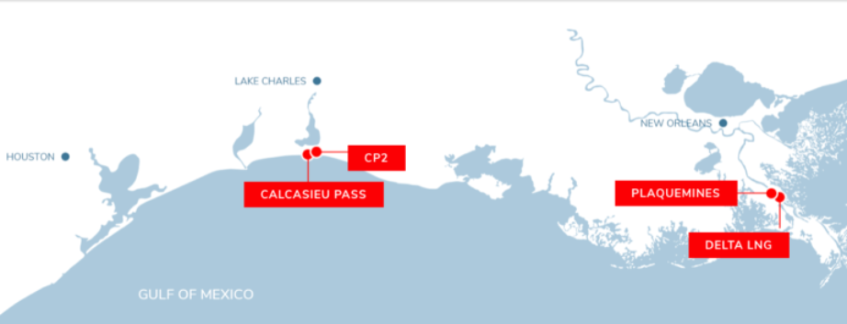
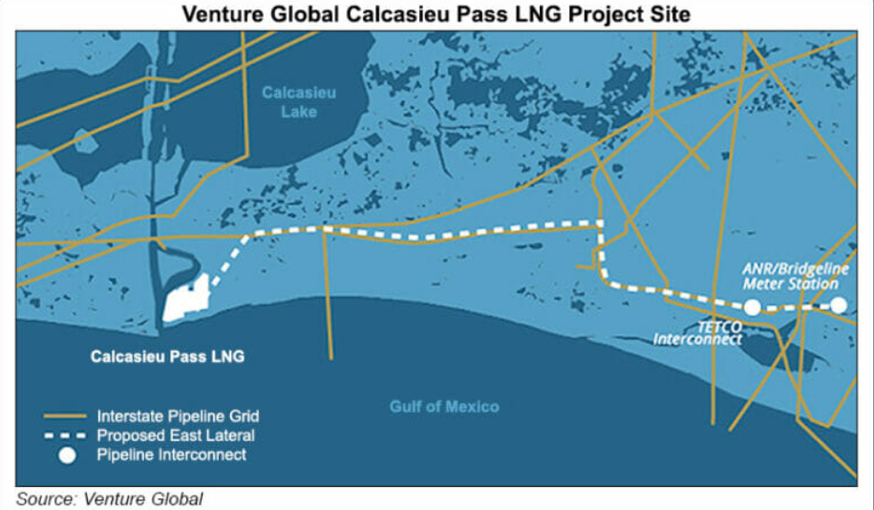
Looking for Oyster Task Force, Plaquemines, and St. Bernard’s support to oppose this project
Rodney Olander motioned to write a letter opposing the Cameron Parish LNG project due to the impacts it will have on the shrimping industry, 2nd by Randy Pearce. Motion carries.
- Haley Gambill led discussion on the 2023 Fisheries Forward Summit panel
The 2023 LA Fisheries Forward Summit will be on March 1st, 2023 there will be an afternoon panel, ‘Opportunities for Innovation’, asking if anyone has an idea or would like to participate in the panel. Please contact Haley Gambill
- The board heard an update on the hiring of the STF lobbist
Waiting on contact to be signed and once that is done it moves to Office of State Purchaing, hope to have this done by the STF Washington, D.C. trip
- Rodney led discussion on having a STF rep come before the St. Mary Tourist Commission to speak about an upcoming program promoting local shrimp
Rodney Olander stated planning a dinner that will bring together all elected officials, asking that the Shrimp Task Force have a representative present to speak on the industry, requested some information on imports and how much LA produces, how many fishermen LA has- would like to give local officials some numbers on what is taking place- they are trying to promote the seafood industry- the program being proposed is if you eat at five selective restaurants and bring receipts to the Tourist Commission you will be rewarded a free t-shirt
Acy Cooper stated that he may be able to come, Rodney Olander stated that he can do the speaking if needed
- The task force considered funding for Shrimp Task Force travel to Washington, D.C. to walk the hill and possibly participate in the LA Alive event
Alan Gibson motioned to approve funding for the Shrimp Task Force travel to Washington, D.C. to pay for room, board and attending the LA Alive event, 2nd by Andrew Blanchard. Motion carries.
Kristen Baumer motioned to set aside $5,000 for emergency Shrimp Task Force travel for calendar year 2023, 2nd by Rodney Olander. Motion carries.
- The task force held officer elections
Andrew Blanchard motioned to nominate Acy Cooper as the Shrimp Task Force chairman, 2nd by Alan Gibson. Motion carries.
Kristen Baumer motioned to nominate Alan Gibson as the Vice- Chairman, 2nd by Rodney Olander. Motion carries.
VIII. Public Comment
Thomas Olander totally oppose the closing of the Gulf and the Vermillion/ Teche Basin area from the inshore out 3 miles, there have been some years that they may have benefited but this past year, for the first time, opened the Gulf a few weeks before the inshore and saw a 15% increase in product, if we had it open all of March and April may be able to increase profits; this closure was initially put into place due to small shrimp being harvested, but that is not an issue any more, believe there is enough things in place that this closure is not needed
Peyton Cagle stated that the closure is due to the 100 count law, as of the 3rd Monday of December the average size, closed based on LDWF data not to stop harvest but to protect the small shrimp- off of Vermillion finding small shrimp each year during this time in western Terrebonne and Vermillion
Acy Cooper stated that he will propose this for a future agenda item for further discussion consideration
IX. The next meeting was set for Wednesday, March 22, 2023 at the Terrebonne Parish Library for 10:00am
X. Kristen Baumer motioned to adjourn the meeting, 2nd by Randy Pearce. Motion carries.

